ALRE
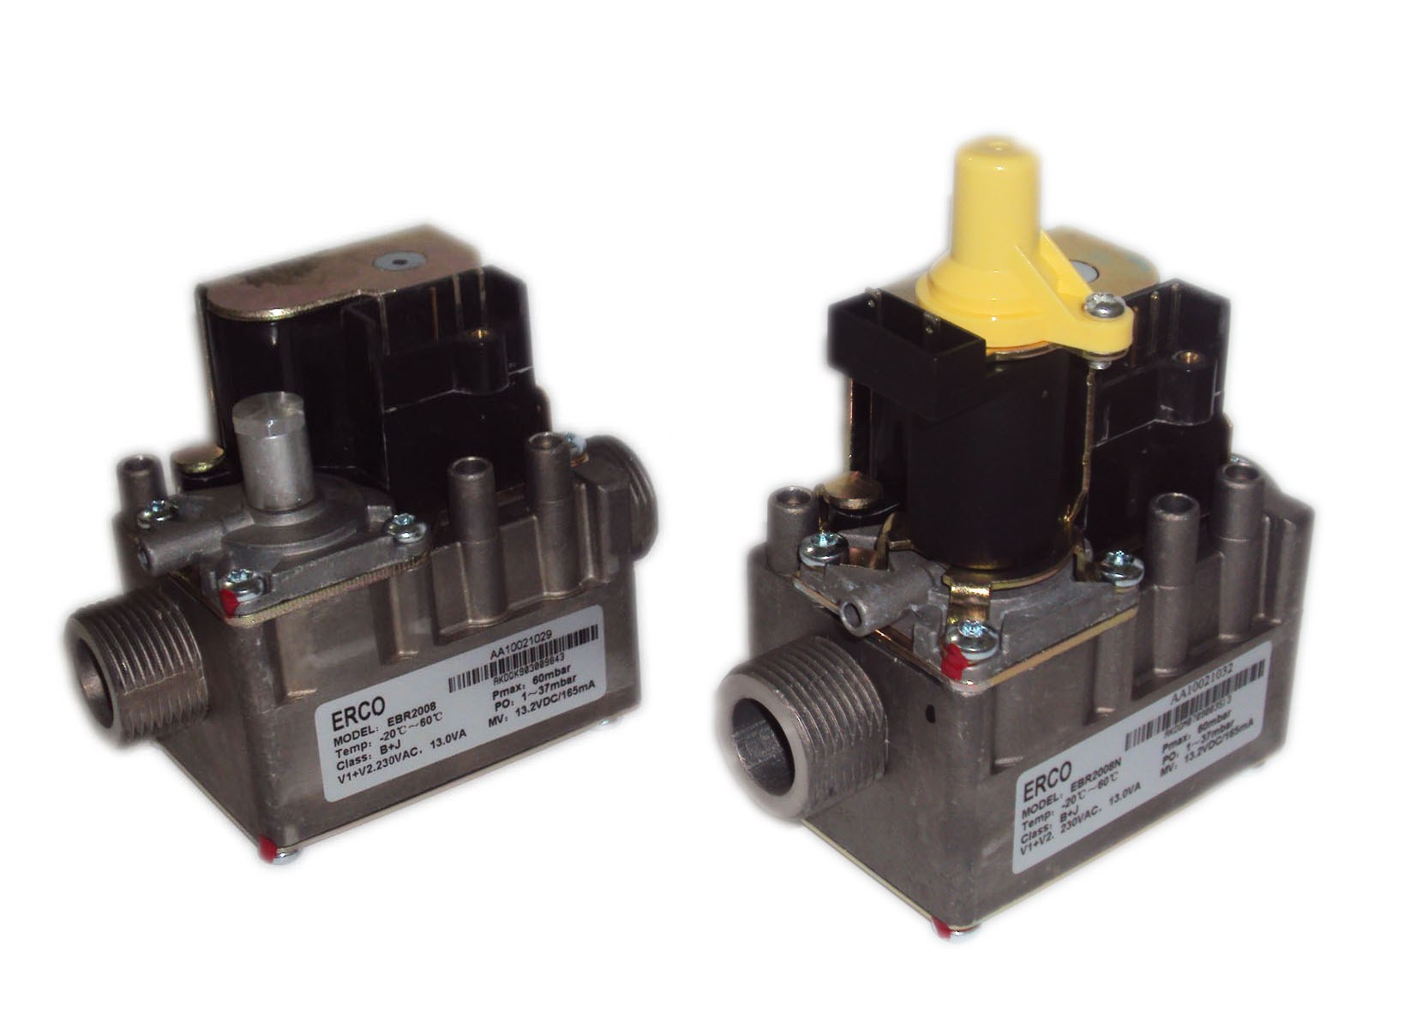
EBR2006N… EBR2008N…
Combination Gas Valves EBR2006N...
EBR2008N...

The combination gas valves type EBR... have been developed for use in gas-fired domestic central heating boilers and water heating appliances with automatic ignition systems. The controls are also suited for use on a wide variety of gas-fired appliances
Use
• Compact design suitable for installation in small modern boilers and heaters
• Specially designed for gas appliance with DBI system to light the main burner
• Servo pressure regulator ensures stable outlet pressure
• Pressure feedback ensures constant burner pressure
Functional options EBR2006N... • Fast and slow opening version for on/off control
• Adjustable slow opening to ensure smooth light-up of burner
EBR2008N... • Modulating control for more comfort and energy savings
Mechanical options • 2 shutoff valves
• Servo pressure regulator
• Inlet/outlet pressure test points
• All adjustments are accessible from the top of valve
• A fine-mesh screen is integrated at the inlet side

CC1N2008cn ALRE
05.05.2009 HVAC Products
Technical data
General unit data Models refer to《Type code》
Mounting position vertical or horizontal±5°
Type of gas CITY-GAS、LNG、LPG
Gas inlet pressure max. 60mbar
Operating voltage tolerance gas valve operates correctly between
85% and 110% of the rated voltage
Degree of protection IP44 with optional connector
Dimensions refer to《Dimensions》
Inlet filter no. 100 fine mesh
Pipe connection inlet and outlet refer to《Type code》
Pressure feedback connection 6.5mm outside dia. for tube
connection
Regulation capacity min. 0.31m³/h air
Outlet pressure range for ON/OFF 1...37mbar
Controller
Outlet pressure range for modulating 1...37mbar
Controller
Valve class EN126
-1st safety shutoff valve class B
-2nd safety shutoff valve class D, class J
Class of regulator EN126
- EBR2006N... class C
- EBR2008N... class C
Closing time of safety shutoff valves within 1S
Weight
-EBR2006N... approx. 870g
-EBR2008N... approx. 980g
Electrical data Power consumption and current
Type | SV1 shutoff valve |  |  | SV2 shutoff valve |  |  | SV1 and SV2 shutoff valve
Type | Voltage | Power | Current | Voltage | Power | Current | Voltage | Power | Current
EBRxx0 | … | … | … | … | … | … | 230VAC | 13VA | 60mA
EBRxx1 | … | … | … | … | … | … | 24VAC | 13VA | 570mA
EBRxx2 | 145VRAC | 8.2VA | 60mA | 85VRAC | 4.8VA | 60mA | 230VRAC | 13VA | 60mA
EBRxx3 | 15.4VRAC | 8.2VA | 570mA | 8.6VRAC | 4.8VA | 570mA | 24VRAC | 13VA | 570mA
EBRxx4 | 230VRAC | 8.2VA | 38mA | 230VRAC | 4.8VA | 22mA | … | … | …
EBRxx5 | 24VRAC | 8.7VA | 380mA | 24VRAC | 4.3VA | 190mA | … | … | …
EBRxx6 | 15.7VDC | 8.5VA | 540mA | 8.3VDC | 4.5VA | 540mA | 24VDC | 13VA | 540mA
EBRxx7 | 24VDC | 8.7VA | 360mA | 24VDC | 4.3VA | 180mA | … | … | …
EBRxx8 | … | … | … | … | … | … | 120VAC | 13VA | 120mA

2/11
ALRE CC1N2008cn
HVAC Products 05.05.2009
Technical data
Only EBR2008N... Electrical modulating pressure regulator
Operating voltage | Current | Resistance
Max. 13.2V | Max. 165mA | 80Ω
Max. 24.8V | Max. 310mA | 80Ω
Note The coils for the safety shutoff function of the EBR... gas valve are DC type.

Pin connections 2 types of terminal arrangements are available for using different types of cable
connectors
Variant 0
Full wave rectifier is integrated in the ignition equipment.
Variant 1

Note：
The coils for safety shutoff function of EBR... gas valve are DC type

3/11
ALRE CC1N2008cn
HVAC Products 05.05.2009
Function
Modulating control Modulating coil：13.2V/165mA
Characteristics of
EBR2008N...
Modulating coil：9V/310mA

4/11
ALRE CC1N2008cn
HVAC Products 05.05.2009
Function
Capacity in m³/h air at Solenoid valve class B+D(J)
pressure differential Flow rate at a pressure drop of 5mbar 4.3m³/h air
Flow chart of classes B and C
EBR2008N-G3/4...
EBR2008N-G1/2...
EBR2006N...

5/11
ALRE CC1N2008cn
HVAC Products 05.05.2009
Function
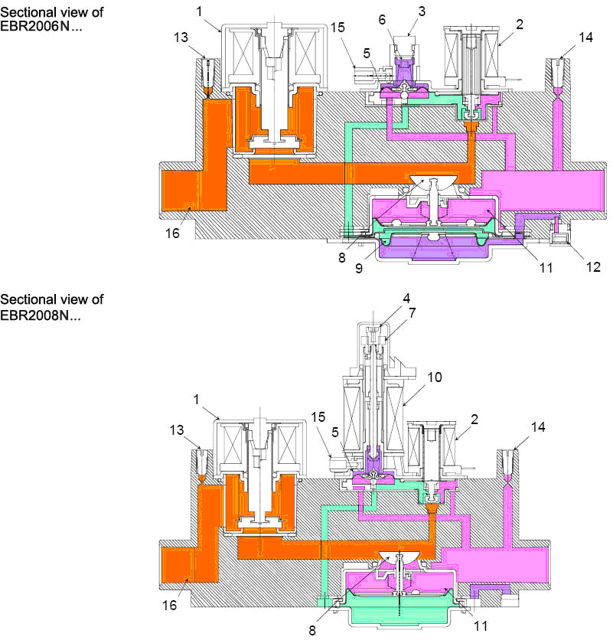

Legend 1 1st shutoff valve(class B) 8 Servo valve
2 2nd shutoff valve 9 Diaphragm for slow opening
3 cap 10 Modulating coil
4 Setting screw minimum outlet pressure 11 Main diaphragm
5 Servo membrane 12 Adjusting screw for slow opening
6 Setting screw for servo pressure 13 Inlet pressure
regulator 14 Outlet pressure
7 Setting screw maximum outlet pressure 15 Combustion chamber feedback pressure
16 Filter
6/11
ALRE CC1N2008cn
HVAC Products 05.05.2009
Warning notes

To avoid injury to persons, damage to property or the environment, following
warning notes must be observed！
Do not open, interfere with or modify the valve!
• All activities (mounting, installation, service work, etc.) must be performed by qualified staff
• Before performing any wiring changes in the connection area of the EBR…, completely isolate the unit from the main supply (all-polar disconnection)
• Ensure protection against electric shock hazard by providing adequate protection for the connection terminals.
• Check to ensure that wiring is in an orderly state
• Fall or shock can adversely affect the safety functions. Such valves must not be put into operation even if the unit does not exhibit any damage
Mounting notes
• Ensure that the relevant national safety regulations are complied with
Outlet pressure of servo pressure regulator –on/off control of EBR2006N…
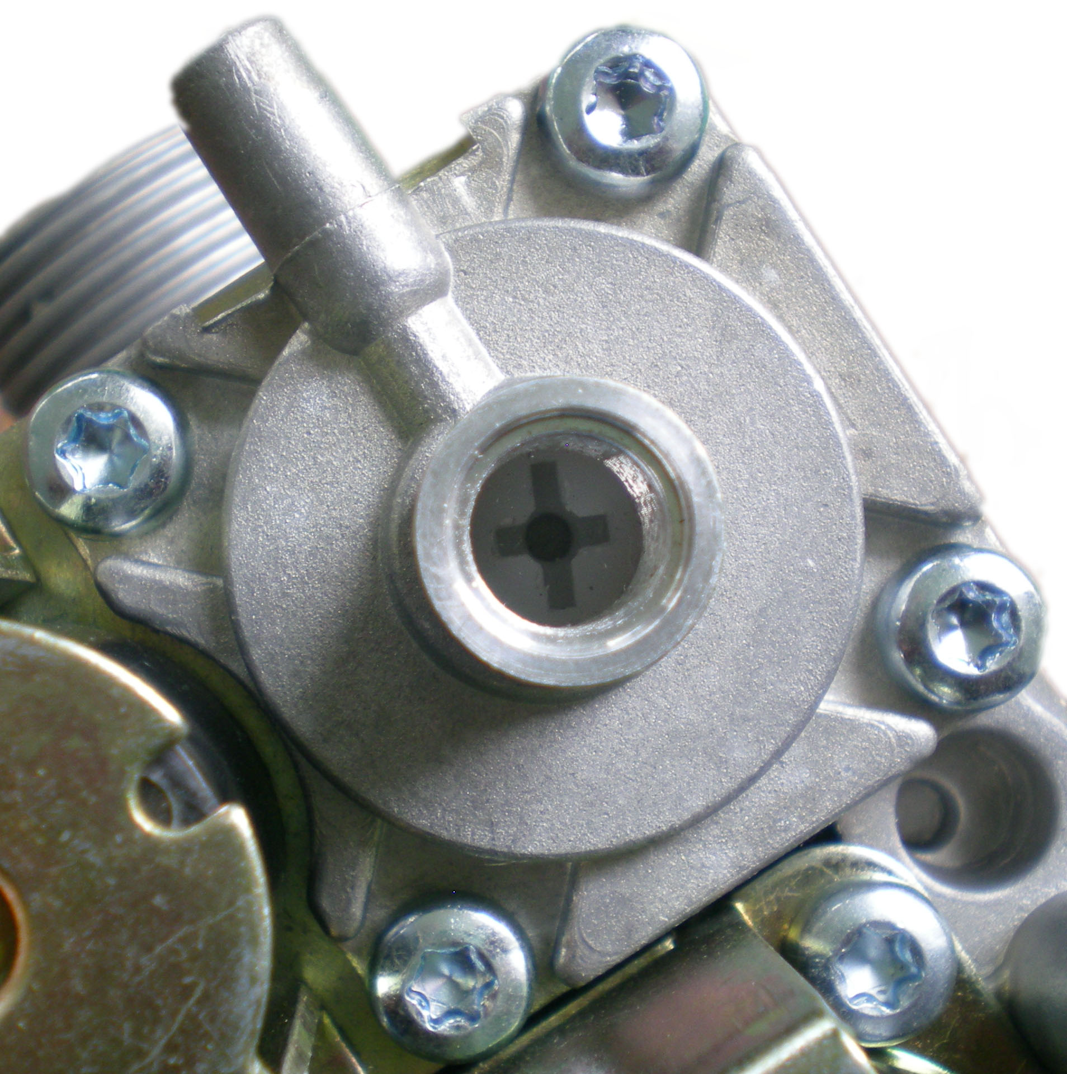
• Check the inlet and outlet pressure using the pressure test points
provided
• Remove the protective cap,
- turn the screw (white) clockwise to increase the outlet pressure
- turn the screw (white) counterclockwise to decrease the outlet
pressure
• Ensure that the outlet pressure is correctly adjusted before replacing
the protective cap
Outlet pressure of servo pressure regulator – modulating control of EBR2008N
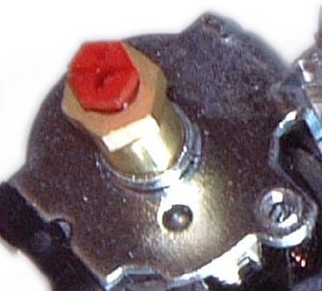
• Check the inlet and outlet pressure using the pressure test points
provided
Remove the protective cap (yellow)
If the inlet pressure is the normal pressure, then add the maximum
Current to the modulating coil.
To set the maximum outlet pressure:
- turn the screw (brass) clockwise to increase the output pressure
- turn the screw (brass) counterclockwise to decrease the output
pressure
• Ensure that the maximum outlet pressure is correctly adjusted with
change of current to the modulating coil.
To set the minimum outlet pressure:
If the inlet pressure is the normal pressure, disconnect the terminals
of the modulating coil (modulating current= 0 mA)
- turn the red screw clockwise to increase the outlet pressure
- turn the red screw counterclockwise to decrease the outlet pressure
• Ensure that the outlet pressure is correctly adjusted, check minimum and maximum setting several times, then tighten the protective cap for protection
7/11
ALRE CC1N2008cn
HVAC Products 05.05.2009
Installation notes
Main gas connection • To prevent distortion and/or damage of the external thread, take care not to
tighten the pipe fitting too far
• Ensure that the gasket is properly placed in the right position
• Ensure that the gas flow is in the same direction as the arrow on the valve body
Pressure test points • The valve is provided with an inlet and outlet pressure test point
• When checking the pressure, undo the screw one half turn and slip the tube
over the nipple

Note Make sure the screw is retightened after making the test.
Electrical connections
Warning Switch off power supply before making the electrical connections. Wiring must
be in accordance with local regulations. Follow the instructions supplied by the
manufacture.
• Install power in accordance with the required pin connection (refer to Function)
• When making connections to the terminals of the valve, use wires and connectors which are suited for temperature up to 105℃
Checkout and • After each adjustment, put the control into operation, run it through several com-
Installation plete cycles and check to ensure that all burner components function correctly
Commissioning notes
• Prior to commissioning the plant, check to ensure wiring is in an orderly state
Service notes
• Each time a unit had been replaced, check to ensure that wiring is in an orderly
state
• Check wiring and all safety functions each time a unit has been replaced
Important Follow the appliance manufacturer’s service and maintenance instructions.
Gas leakage test • The gas valves are factory-tested for gas leakage. Only the main burner
connection needs to be checked for gas leakage

8/11
ALRE CC1N2008cn
HVAC Products 05.05.2009

Disposal
The unit contains electric components and must not be disposed of together with
Household waste.
Local and currently valid legislation must be observed.
Accessories
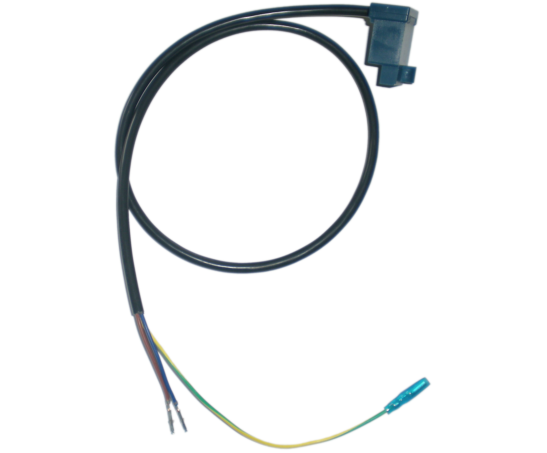
Ignition Equipment, combined with connecting cable
The PEC… consists of a cable for connection to the safety
shutoff valves of the EBR… gas valves and electronic PEC…
ignition equipment for use on gas boilers with signal- or
double-pole ignition.

Note Ignition Equipment has two types: PEC1 is used for gas valve with AC type. PEC2 is used for gas valve with DC type.

Condensation, formation of ice and ingress of water are not permitted！
Life cycle • Combination Gas Valves type EBR2006N... / EBR2008N... has a designed
lifetime* of 250,000 burner startup cycles which, under normal operating
conditions in heating mode, correspond to 10 years of usage.

The designed lifetime is based on use of the Combination Gas Valves
According to the manufacturer’s operating instructions.

After reaching the designed lifetime in terms of the number of burner startup
cycles, or the respective time of usage, the Combination Gas Valves is to be
replaced by authorized personnel.

* The designed lifetime is not the warranty time specified in the Terms of
Delivery.

9/11
ALRE CC1N2008cn
HVAC Products 05.05.2009
Dimensions
Dimensions in mm
EBR2008N...

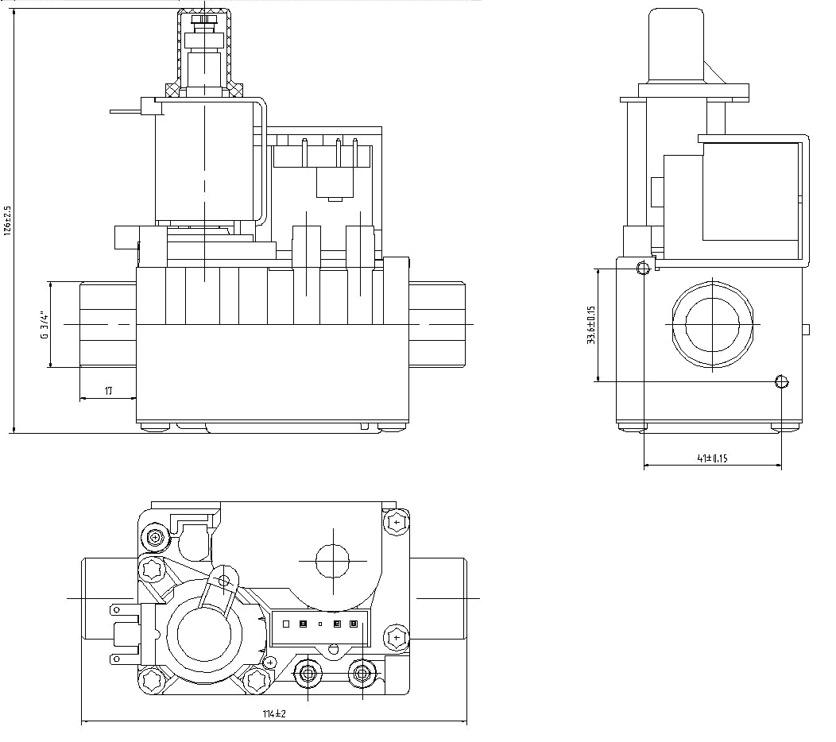

10/11
ALRE CC1N2008cn
HVAC Products 05.05.2009
Dimensions
Dimensions in mm
EBR2006N...
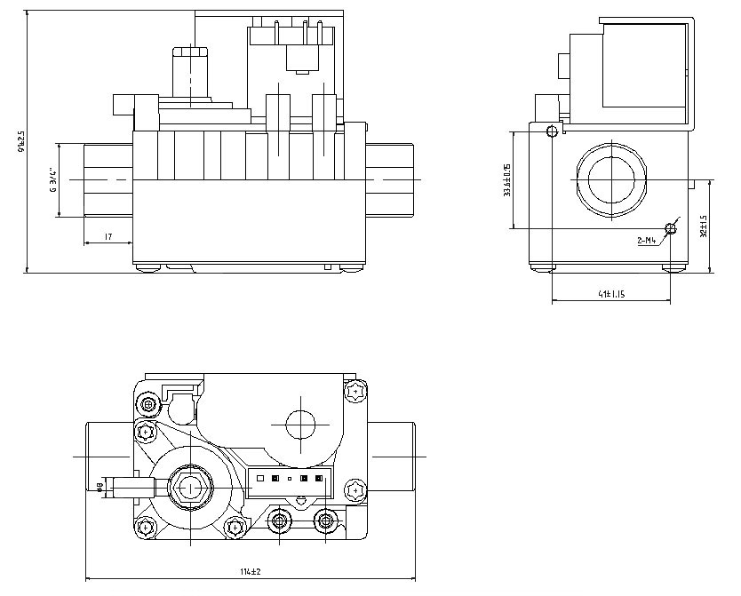

11/11
ALRE CC1N2008cn
HVAC Products 05.05.2009

